 | 13.1.9 Editors - Shader Editor - Header - Add Menu - Color
Table of content
Detailed table of content 1
Add menu - Color 5
Blackbody 5
Brightness/Contrast 5
Color Ramp 6
Gamma 8
Hue Saturation Value 8
Invert Color 9
Light Falloff 10
Mix Color 10
RGB Curves 12
Wavelength 14
Combine Color 15
Separate Color 15
RGB to BW 16
Shader to RGB 16

Detailed table of content
Detailed table of content
Detailed table of content 1
Add menu - Color 5
Blackbody 5
Inputs 5
Temperature 5
Outputs 5
Color 5
Brightness/Contrast 5
Inputs 5
Color 5
Brightness 5
Contrast 5
Outputs 6
Color 6
Color Ramp 6
Inputs 6
Factor 6
Properties 6
Color Ramp 6
Controls 6
+ 6
- 6
Tools menu 6
Flip Color Ramp 6
Distribute Stops from Left 6
Distribute Stops Evenly 6
Eyedropper (pipette icon) E 7
Reset Color Ramp 7
Color Mode 7
RGB 7
HSV/HSL 7
Interpolation 7
Ease 7
Cardinal 7
Linear 7
B-Spline 7
Constant 7
Color Ramp 7
Active Color Stop elements 7
Choose active color stop 7
Pos 7
Outputs 7
Image 7
Alpha 8
Gamma 8
Inputs 8
Color 8
Gamma 8
Outputs 8
Color 8
Hue Saturation Value 8
Inputs / Properties 8
Hue 8
Saturation 8
Value 8
Factor 8
Color 9
Outputs 9
Color 9
Invert Color 9
Inputs 9
Factor 9
Color 9
Outputs 9
Color 9
Light Falloff 10
Inputs 10
Strength 10
Smooth 10
Outputs 10
Quadratic 10
Linear 10
Constant 10
Mix Color 10
Data Type 11
Color 11
Inputs 11
Factor 11
Color 1 11
Color 2 11
Properties 11
Mix 11
Clamp Result 11
Clamp Factor 11
Outputs 11
Result 11
Vector 11
Inputs 11
Factor 11
A 11
B 11
Properties 12
Factor Mode 12
Clamp Factor 12
Outputs 12
Result 12
Float 12
Inputs 12
Factor 12
A 12
B 12
Properties 12
Clamp Factor 12
Outputs 12
Result 12
RGB Curves 12
Inputs 12
Factor 12
Color 13
Properties 13
Curve Field 13
Channel buttons 13
Navigation elements 13
Zoom in and out 13
Use Clipping 13
Tools 13
Reset View 13
Extend horizontal 13
Extend extrapolated 13
Reset Curve 13
Curve edit field 13
Selecting Points 14
Adding Points 14
Curve point settings 14
Vector Handle 14
Auto Handle 14
Auto Clamped Handle 14
Outputs 14
Color 14
Wavelength 14
Inputs 14
Wavelength 14
Outputs 15
Color 15
Combine Color 15
Input 15
Mode 15
Input – RGB mode 15
R, G and B 15
Input – HSV mode 15
H , S and V 15
Input – HSL mode 15
H , S and L 15
Outputs 15
Color 15
Separate Color 15
Input 16
Mode 16
Image 16
Output 16
Red, Green, Blue and Alpha 16
Hue Saturation Value Alpha 16
Hue Saturation Lightness Alpha 16
RGB to BW 16
Inputs 16
Color 16
Outputs 16
Val 16
Shader to RGB 16
Inputs 17
Shader 17
Outputs 17
Color 17
Alpha 17

Add menu - Color

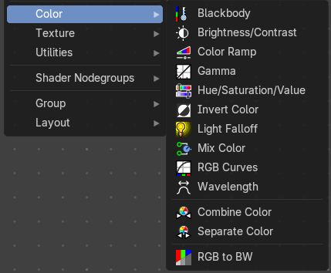
This sub menu contains color related nodes.

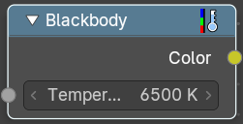
Blackbody
Convert a blackbody temperature to an RGB value.

Inputs

Temperature
Standard input.

Outputs

Color
Standard output.

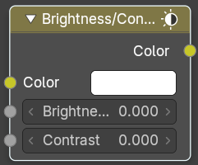
Brightness/Contrast

Inputs

Color
Standard input.

Brightness
An additive-type factor by which to increase the overall brightness of the image. Use a negative number to darken an image.

Contrast
A scaling type factor by which to make brighter pixels brighter, but keeping the darker pixels dark. Higher values make details stand out. Use a negative number to decrease the overall contrast in the image.

Outputs

Color
Standard output.
Note. It is possible that this node will put out a value set that has values beyond the normal range, i.e. values greater than one and less than zero. If you will be using the output to mix with other images in the normal range, you should clamp the values using the Map Value node (with the Min and Max enabled), or put through a Color Ramp node (with all normal defaults).

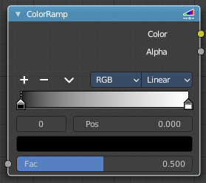
Color Ramp
The Color Ramp Node is used for mapping values to colors with the use of a gradient.

Inputs

Factor
The Factor input is used as an index for the color ramp.

Properties

Color Ramp
Color Ramps enables the user to specify a range of colors based on color stops. The color between the color stops gets interpolated.

Controls

+
Add a stop to your color ramp. The stop will be added after the selected one, in the middle to the next one.

-
Deletes the selected color stop from the list.


Tools menu

Flip Color Ramp
Flips the gradient, inverting the values of the color ramp.

Distribute Stops from Left
Rearrange the stops so that every step has the same space to the right.

Distribute Stops Evenly
Space between all neighboring stops becomes equal.

Eyedropper (pipette icon) E
An Eyedropper to sample a color or gradient from the interface to be used in the color ramp.

Reset Color Ramp

Resets the color ramp to its default state.

Color Mode

RGB
Blends color by mixing each color channel and combining.

HSV/HSL
Blends colors by first converting to HSV or HSL, mixing, then combining again. This has the advantage of maintaining saturation between different hues, where RGB would de-saturate, this allows for a richer gradient.


Interpolation

Ease
Uses an Ease Interpolation for the color stops.

Cardinal
Uses a Cardinal Interpolation for the color stops.

Linear
Uses a Linear Interpolation for the color stops.

B-Spline
Uses a B-Spline Interpolation for the color stops.

Constant
Uses a Constant Interpolation for the color stops.

Color Ramp
The color band. A click at one of the color stops makes it the active one. You can move the color stops by clicking at them and dragging them around.

Active Color Stop elements

Adjust the active color stop.

Choose active color stop
Choose the color stop by index.

Pos
The position of the active color stop. The range goes from 0.000 to 1.000

Outputs

Image
Standard image output.

Alpha
Standard Alpha Output.

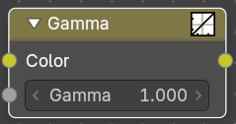
Gamma
Use this node to apply a gamma correction.

Inputs

Color
Standard image input.

Gamma
An exponential brightness factor.

Outputs

Color
Standard output.

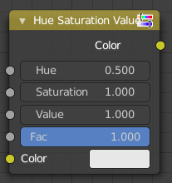
Hue Saturation Value
The Hue Saturation Node applies a color transformation in the HSV color space. Called “Hue Saturation Value” in shader and texture context.

Inputs / Properties
The inputs also works as properties when nothing is connected.

Hue
Specifies the hue rotation of the image. 360° are mapped to (0 to 1). The hue shifts of 0 (-180°) and 1 (+180°) have the same result.

Saturation
A saturation of 0 removes hues from the image, resulting in a greyscale image. A shift greater than 1.0 increases saturation.

Value
Value is the overall brightness of the image. De/Increasing values shift an image darker/lighter.

Factor
Controls the amount of influence the node exerts on the output image.

Color
Standard input.

Outputs

Color
Standard output.
Hue/Saturation Tips
Some things to keep in mind that might help you use this node better:
Hues are vice versa
A blue image, with a Hue setting at either end of the spectrum (0 or 1), is output as yellow (recall that white, minus blue, equals yellow). A yellow image, with a Hue setting at 0 or 1, is blue.

Hue and Saturation work together.
So, a Hue of 0.5 keeps the blues the same shade of blue, but Saturation can deepen or lighten the intensity of that color.
Gray & White are neutral hues
A gray image, where the RGB values are equal, has no hue. Therefore, this node can only affect it with Value. This applies to all shades of gray, from black to white; wherever the values are equal.
Changing the effect over time
The Hue and Saturation values can be animated with a Time Node or by animating the property.

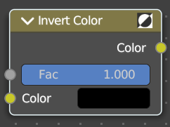
Invert Color
The Invert Node inverts the colors in the input image, producing a negative.

Inputs

Factor
Controls the amount of influence the node exerts on the output image.

Color
Standard input.

Outputs

Color
Standard image output.

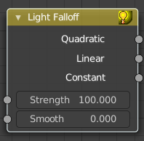
Light Falloff
Cycles Only
The Light Falloff node allows you to manipulate how light intensity decreases over distance. In reality light will always fall off quadratically; however, it can be useful to manipulate as a non-physically-based lighting trick. Note that using Linear or Constant falloff may cause more light to be introduced with every global illumination bounce, making the resulting image extremely bright if many bounces are used.

Inputs

Strength
Light strength before applying falloff modification.

Smooth
Smooth intensity of light near light sources. This can avoid harsh highlights, and reduce global illumination noise. 0.0 corresponds to no smoothing; higher values smooth more. The maximum light strength will be strength/smooth.

Outputs

Quadratic
Quadratic light falloff; this will leave strength unmodified if smooth is 0.0 and corresponds to reality.

Linear
Linear light falloff, giving a slower decrease in intensity over distance.

Constant
Constant light falloff, where the distance to the light has no influence on its intensity.

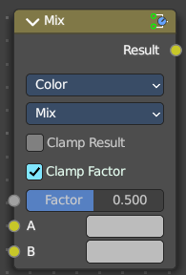
Mix Color
The mix Color node is in real the Mix node in Color mode. It is shared across editors.
The Mix node is meant to mix values. This can be colors, or also a vector or a single value.
Note that the Mix Color node does not start in Color mode when you insert it from the sidebar due a techical limitation in the Blender Python api. Here you have to manually switch to the color mode.

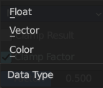
Data Type
The mode in which the node works.

Color
The Mix Node in color mode mixes images by working on the individual and corresponding pixels of the two input images. Called “MixRGB” in the shader and texture context.

Inputs

Factor
Controls the amount of influence the node exerts on the output image.

Color 1
Usually the background image. The image size and resolution sets the dimensions of the output image.

Color 2
Usually he foreground image.

Properties

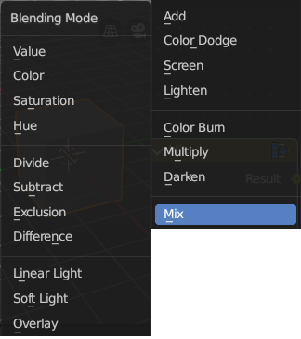
Mix
Choose the different blending modes.
Add, Subtract, Multiply, Screen, Divide, Difference, Darken, Lighten, Overlay, Color Dodge, Color Burn, Hue, Saturation, Value, Color, Soft Light, Linear Light.

Clamp Result
Clamp the result to 0, 1 range.

Clamp Factor
Clamp the factor to 0, 1 range.

Outputs

Result
Standard output.

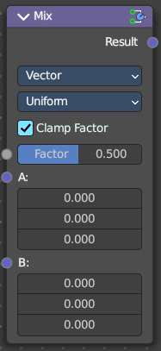
Vector
The vector mode allows you to mix vectors.

Inputs

Factor
Controls the amount of influence.

A
The input vector.

B
The output vector.

Properties

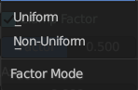
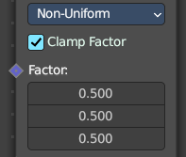
Factor Mode
Use a single factor for all values, or a factor per value.

Clamp Factor
Clamp the factor to 0, 1 range.

Outputs

Result
Standard output.

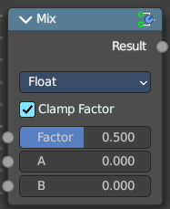
Float
The vector mode allows you to mix vectors.

Inputs

Factor
Controls the amount of influence.

A
The input value.

B
The output value.

Properties

Clamp Factor
Clamp the factor to 0, 1 range.

Outputs

Result
Standard output.

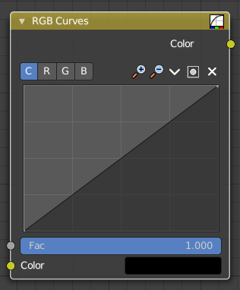
RGB Curves
The RGB Curves Node allows color corrections for each color channel and levels adjustments in the compositing context.

Inputs

Factor
Controls the amount of influence the node exerts on the output image.

Color
Standard image input.

Properties

Curve Field

Channel buttons
Clicking on one of the channels displays the curve for each.
C (Combined RGB), R (Red), G (Green), B (Blue).

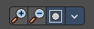
Navigation elements
They are described from left to right.

Zoom in and out
The two buttons with the magnifying glass at it zooms in and out in the curve window.


Use Clipping
Clipping options. Set up clipping for the stroke.

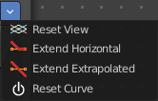
Tools
Tools is a menu where you can find some curve related tools.

Reset View
Resets the curve windows zoom.

Extend horizontal
Extends the curve before the first curve point and behind the last curve point horizontally.

Extend extrapolated
Extends the curve before the first curve point and behind the last curve point extrapolated.

Reset Curve
Resets the curve to the initial shape.

Curve edit field
Create and tweak a Bezier curve that varies the input levels (X axis) to produce an output level (Y axis).

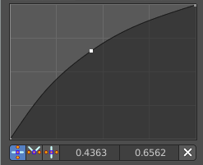
Selecting Points
You can select curve points. This reveals two edit boxes for the x and y coordinate of this point.
Selected points can be moved around. Left click at them, hold the mouse button down and move them to a new location.

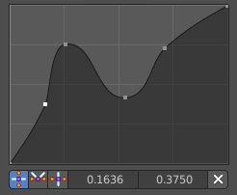
Adding Points
You can add new curve points by simply left clicking at the curve. Move the mouse to position them where you need it.

Curve point settings
When you have a point selected then you will reveal further settings at the bottom.

Vector Handle
Set handle type to Vector.

Auto Handle
Set handle type to Auto.

Auto Clamped Handle
Set handle type to Auto Clamped.

Outputs

Color
Standard output.

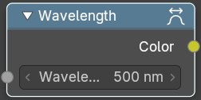
Wavelength
Convert a Wavelength value to a RGB value.

Inputs

Wavelength
The wavelength input.

Outputs

Color
Standard output.

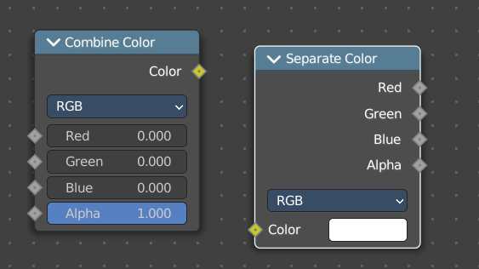
Combine Color
Combine the single RGBA channels into a single image.

Input

Mode
- RGB colour processing
- HSV colour processing
- HSL colour processing

Input – RGB mode

R, G and B
The red, green and blue channels of an image.

Input – HSV mode

H , S and V
The Hue, Saturation and Value channels of an image.

Input – HSL mode

H , S and L
The Hue, Saturation and Luminescence channels of an image.

Outputs

Color
The rgba output color.

Separate Color
Combine the single RGBA channels into a single image.

Input

Mode
- RGB colour processing
- HSV colour processing
- HSL colour processing

Image
The image input.

Output

Red, Green, Blue and Alpha
The red, green, blue and alpha channels of an image in RGB mode.

Hue Saturation Value Alpha
The Hue Saturation Value Alpha channels in HSV mode.

Hue Saturation Lightness Alpha
The Hue Saturation Lightness Alpha channels in HSL mode.

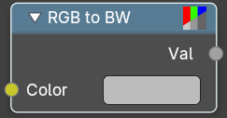
RGB to BW
Convert a 24 bit RGB value to a 8 bit black and white value.

Inputs

Color
Standard output.

Outputs

Val
Standard output.

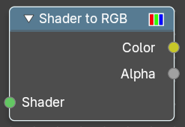
Shader to RGB
Convert rendering effects to RGB value. Eevee only.

Inputs

Shader
Standard output.

Outputs

Color
Color output.

Alpha
Alphachannel output.

